**Objective:**

The objective of this project is to analyze student scores across different subjects using R programming. The project aims to perform basic statistical analysis, visualize the data, and provide insights into student performance.

Dataset:

For this project, we will create a sample dataset containing student names and their scores in multiple subjects**.**

**Methodology:**

1. **Data Collection**: A sample dataset containing student names and their scores in Math, Science, and English was created.
2. **Statistical Analysis**: Basic statistical functions such as mean, median, and standard deviation were calculated for each subject.
3. **Data Visualization**: Various visualizations, including bar plots and box plots, were created to represent the score distribution.
4. **Insights and Interpretation**: The results were interpreted to identify trends and patterns in student performance.

**Technologies Used:**

* **Programming Language**: R
* **Libraries**: **dplyr**, **ggplot2**, **tidyr**
* **Environment**: RStudio

**Step-by-Step Implementation**

**Step 1: Set Up Your R Environment:**



**Step 2: Create a Sample Dataset:**

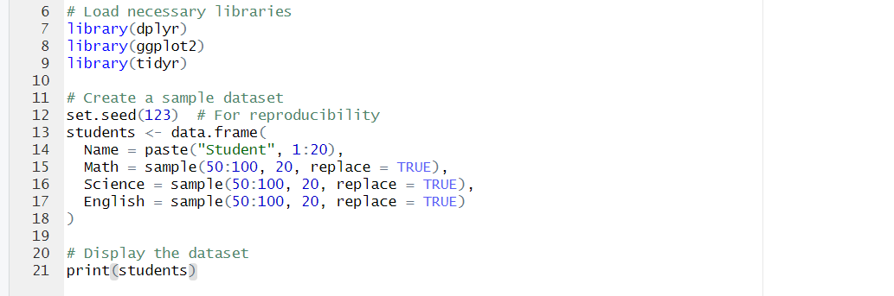

**Step 3: Perform Basic Statistical Analysis:**

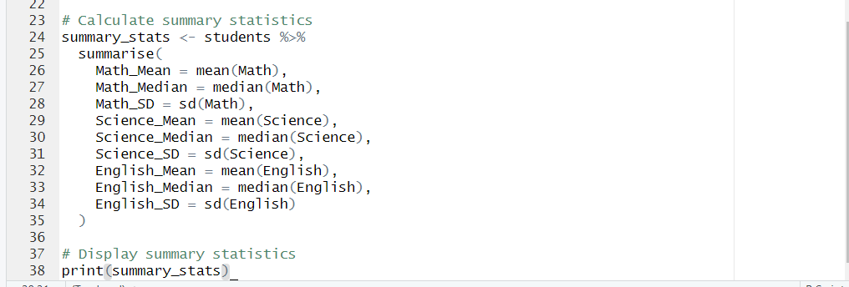

**Step 4: Create Visualizations:**

**1>Bar Plot of Average Scores**

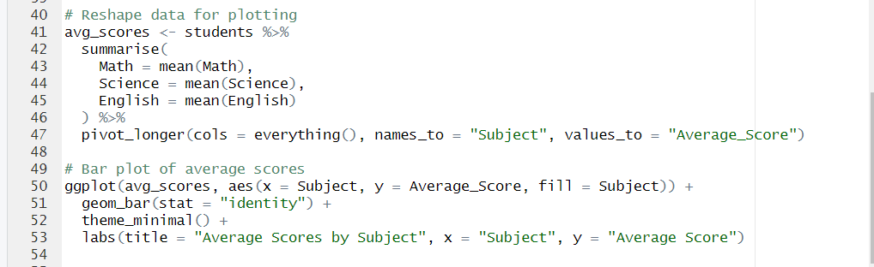

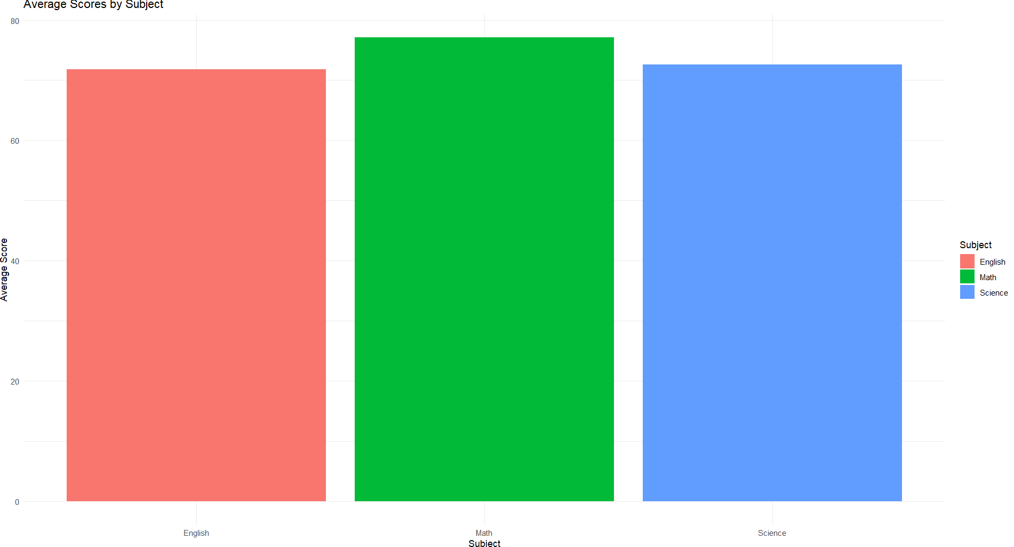

**2>Box Plot of Scores**

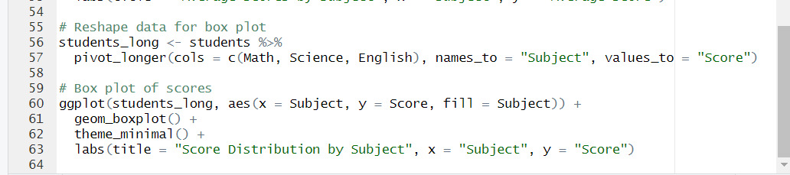

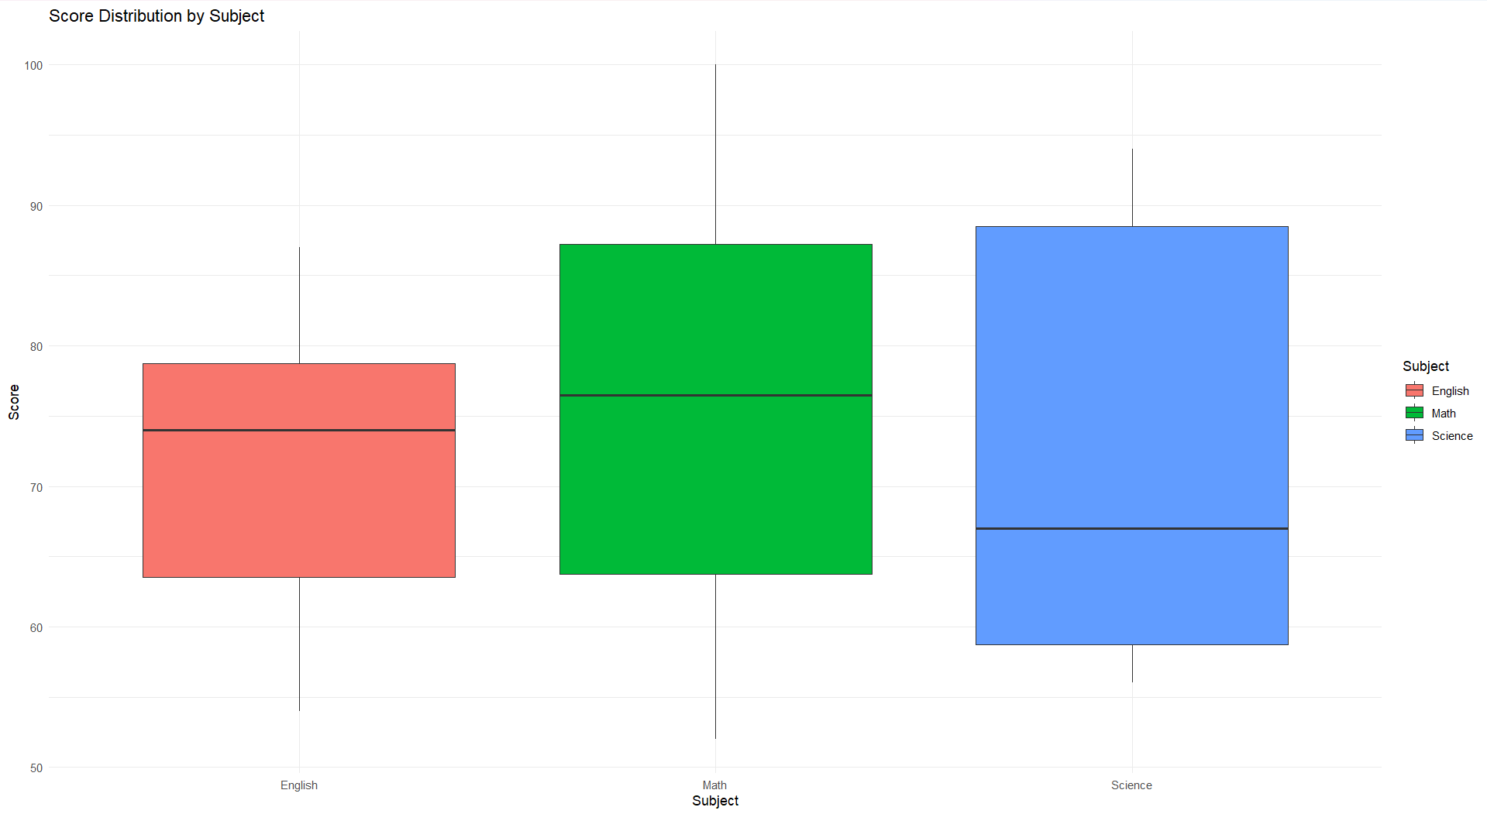

**Conclusion and Insights:**

After completing the analysis and visualizations, we can summarize the findings as follows:

1. **Average Scores**: The bar plot provides a clear visual representation of the average scores across subjects, allowing us to quickly identify which subjects students performed best in.
2. **Score Distribution**: The box plot illustrates the spread of scores for each subject, highlighting any outliers and the overall distribution of scores.
3. **Highest and Lowest Scorers**: Identifying the highest and lowest scorers in each subject can help educators understand individual student performance

**Learning Outcomes :**

1. **Data Manipulation Skills**:
   * Gain proficiency in using R for data manipulation and transformation using packages like **dplyr** and **tidyr**.
   * Learn how to create and reshape data frames to prepare data for analysis and visualization.
2. **Statistical Analysis**:
   * Understand basic statistical concepts such as mean, median, and standard deviation.
   * Learn how to compute these statistics for different groups within a dataset, enhancing your ability to summarize and interpret data.
3. **Data Visualization**:
   * Develop skills in creating various types of visualizations using **ggplot2**, including bar plots, box plots, and line plots.
   * Learn how to effectively communicate data insights through visual means, making complex data more accessible and understandable.
4. **Interpretation of Results**:
   * Enhance your ability to interpret statistical results and visualizations, drawing meaningful conclusions from the data.
   * Learn to identify trends, patterns, and outliers in the data, which can inform decision-making and further analysis.